# ECE 479/579 Digital Control Systems

Final Project and Exam (Due: May 4, 2016)

Name: Bo Lin Grade:

State-Space Design of Digital Controller:

The double mass-spring device described in Appendix A.4 is representative of many devices that have some structural resonances. Placing the sensor so that it measures *y* is called the collocated case; whereas placing it so that it measures *d* is called the non-collocated case.

* System analysis part:

Before working on the controller design part, you need to study Appendix A.4, research online and find a practical system that can be represented by the double mass-spring device. Provide a report for your study and analysis on how the double mass-spring device as well as the above stated control requirements is related to the practical system.

* Digital controller design part:

Often, the designer is not aware initially that a resonance exists in the system, a situation that is addressed by the following design part.

For *M=20kg*, *m=1kg*, *k=25N/m*, and *b=0.2N-sec/m*, we obtain a resonance frequency of 5rad/sec with a damping ratio, **=0.02.

1. To represent the case where the designer did not know about the resonance, assume the coupling is rigid, that is, *k* is infinite. The transfer function is then



Design a digital controller (**K** and **Lp**) with *T*=200msec, control poles at *z*=0.75j0.2, and estimator poles at *z*=0.3j0.3. Verify by simulation that provides a response to a unit-step command using the state-commend input structure that is consistent with the selected poles.

1. Use the controller (**K** and **Lp**) obtained in part (a) in a simulation of the system where the infinite spring is replaced with flexible one and the output is *d*, that is, a fourth-order

plant with second-order controller. Examine the response and compare it qualitatively with an analysis of the close-loop roots of this combined system.

1. Repeat part (b), but replace the plant output, *d*, with *y*.
2. Analyze where the roots of the system would be if you measured *y* and *y* directly (no estimator) and fed them back using your **K** from part (a).



1. Design a fourth-order digital controller with control poles at *z*=0.75j0.2, 0.4j0.6 and estimator poles at *z*=0.3j0.3, 0j0.4 with *d* as the measurement. Again verify by simulation that it provides the correct response to a unit-step command using the state- commend input structure.
2. Plot the frequency response of the compensation (control plus estimator) from part (e). State why you think this kind of compensation is usually referred to as a notch filter.
3. Plot the *z*-plane root locus of the system (plant plus controller) and comment on the sensitivity of this design to changes in the overall loop gain.
4. **Simulation requirement:** For parts (a), (b), (c) and (e), simulation using both m-file and Simulink is required; both discrete and mixed signal simulation in Simulink are required; comparison among different simulation approaches should be provided.

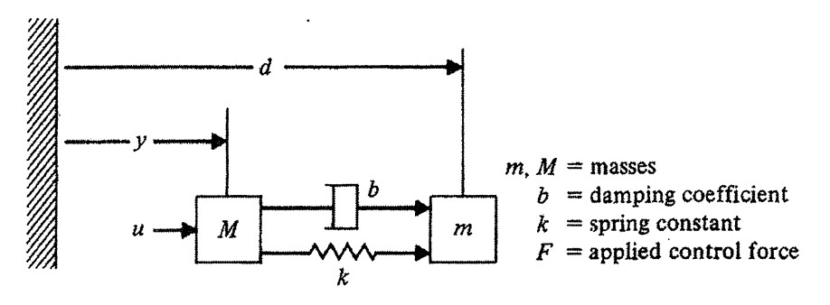

Fig. 1. Double-mass spring system

# Grading Policy

* + Project report (160)

You will be required to submit a formal typed report on your design. The format of the design report will be left to you. However, a large portion of your ultimate grade on this part will be determined by the completeness, accuracy, style, and brevity of your report. You should address the problem statement, the technical approach to your solution, etc. Include output data, algorithms, etc.

1. System analysis part (20)
2. Digital controller design part: 20 points for each small question.

o Simulation files required: The simulation files should include the code of the m- files that you develop. Detailed documentation of the code is required. The format of the documentation will be left to you. However, a large portion of your grade on this part will be determined by the completeness, accuracy, style, and brevity of the documentation. You must include a printout of the code as an appendix.

* + Project presentation (40)

The format of the presentation will be left to you. However, a large portion of your ultimate grade on this part will be determined by the completeness, accuracy, style, and brevity of your presentation. You should address the problem statement, the technical approach to your solution, result analysis, etc.

* + Upload your report, presentation, and simulation files by the project due date.